

Access Change Control

Procedure

STATUS INFORMATION

Security classification: | Confidential |  | State: | Final
Current version number: | 1.0 | Date of first issue: |  | 02/05/2008
Prepared by: | Nourou Dine Issaka |  | Date: | 02/05/2008
Verified by: | Nicolas Macaire |  | Date: | 02/05/2008
Approved by: | Julien Andrieux |  | Date: | 06/05/2008
Document owner: | Julien Andrieux
Copyright notice
This document may not be reproduced (even partially) or communicated to third parties without the written authorization of the company’s General Management.
DISTRIBUTION LIST
Name | Address | I/A/V
Julien Simon | julien.simon@digiplug.com | V/A
Julien Andrieux | julien.andrieux@digiplug.com | V/A
DIGIPLUG Managers |  | I/A
IT Operations Team |  | I/A
IT Development Team | dev@digiplug.com | I/A
IT Architecture Team |  | I/A
Nicolas Tavier | Nicolas.tavier@accenture.com | I
Morgan Ledu | Morgan.ledu@accenture.com | I
Moulay Younes Alaoui Rizq | moulay.y.alaoui-rizq@accenture.com | I
Nicolas Macaire | nicolas.macaire@accenture.com | I
Nourou Dine Issaka | nourou.dine.issaka@accenture.com | I
(I = for information, A = for action, V=for validation)
DOCUMENT CHANGE RECORD
Version | Date | Description | Affected sections
V0.1 to 0.6 | 19/05/2008 | Initialization | All
V1.0 | 02/06/08 | Final | All
IT Contact PEople
Function | Name
IT Lead | Julien Andrieux
IT Consultant | Moulay Younes Alaoui-Rizq
IT Consultant | Nicolas Macaire
IT Consultant | Nourou Dine Issaka

Table of content
1 Introduction 5
1.1 Definition and Purpose 5
1.2 Scope 5
1.3 Glossary 5
2 Roles and responsibilities 6
3 High level change procedure flow 8
4 Change procedure description 9
4.1 Change recording 9
4.2 Change processing (approval) 9
4.3 Change scheduling 9
4.4 Change building/testing 10
4.5 Change implementation 10
4.6 Change validation and review 10

Introduction

Definition and Purpose

Change Management is a set of standardized methods and procedures used for efficient and prompt handling of all changes to a controlled IT infrastructure, in order to minimize the number and impact of any related incident upon service.

The primary objective of the Change Management process is to reduce the risk associated with changes to business operations, thus ensuring that the best possible levels of service quality are maintained.

Other supporting objectives include:
  - Provide a consistent and standardized approach to coordinate Change Management across all business units and provide continuity of service;
  - Maintain consistent processes and procedures, and quality approaches while implementing changes;
  - Document and track all infrastructure changes;

  - Improve efficiency and minimize the impact of re-work;

  - Provide change-related statistics, reports for management;
  - Provide clear communication channels to balance and prioritize changes;
  - Define roles and responsibilities and identify appropriate contacts;
  - Promote status communication.

Scope

The scope of this document is to describe the procedure to manage any access change related to Digiplug/UMGI production platform system. The different types of accesses and related rules are defined in the “Access policy” and “Security management procedure” documents.

Glossary

These acronyms will be used further in this document.

  - FSC (Forward schedule of change): A schedule that contains details of all the Changes approved for implementation and their proposed implementation dates.
  - PIV (Post implementation verification): this step deals with verifying the change after it is successfully deployed to the production environment.
  - PRR (Production readiness review): this procedure ensures the readiness of a major change before it is implemented.
  - RFC (Request for change): it is a mandatory form used to record details of a request for a change to any configuration item, for a new service or for an incident correction.

Roles and responsibilities

Roles | Description
Change Manager | The Change Manager is responsible for implementing the changes to the accesses on the production environment.  Responsibilities include:  - Validating and successfully executing the Change Management procedure;  - Serving as a point of contact for all Change Management related process inquiries;  - Identifying and coordinating with all other process owners on process integration points;  - Driving for the efficiency and effectiveness of the Change Management Procedure;  - Assigning teams to conduct request for change (RFC) impact analysis and risk assessments;  - Analyzing, prioritizing, categorizing, approving and scheduling RFCs;  - Having the main role in the RFC approval procedure;  - Providing change notification to affected parties;  - Monitoring the successful completion of all RFCs, including change planning, building, testing, and implementing the change;  - Ensuring that risk and impact analysis is performed for each change;  - Reviewing test plan and results when applicable;  - Coordinating development, acceptance and sign-off of the Production Readiness Review;  - Reviewing the implemented change and communicating the findings to appropriate managers and stakeholders;  - Handling communication of the status of changes to the client within lower support levels.
IT Operations Team | When a change to Digiplug production platform access is identified, the Change Manager engages the IT Operations Team to verify the production environment changes (Ex: new account, modification of the rights, etc) that might be required for the successful deployment of the Change.  Responsibilities include:  - Providing Change Manager with inputs to prepare the PRR;  - Verifying that the production/operation environment is ready for change deployment;  - Executing the deployment of the change;  - Performing the Post Implementation Verification (PIV).
Test Team | The Test Team performs testing on the Changes. When a change to an access is identified, the Change Manager engages the Test Team to help testing the change.  Responsibilities include:  - Providing Change Manager with inputs to prepare the Production Readiness Review (PRR);  - Performing testing on changes.

High level change procedure flow

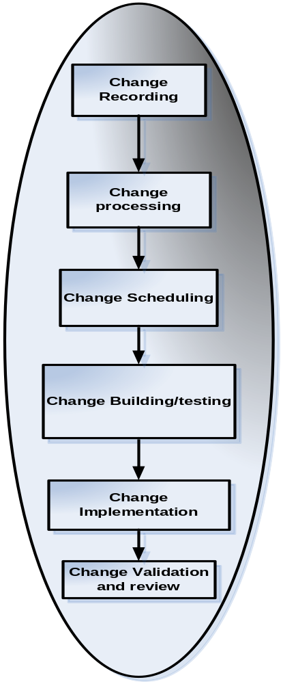

Image 1: Change management high level procedure flow

Change procedure description

Change recording

Change on accesses can be required to solve a problem on the production platform or in the case of a particular event. Once identified, a Problem or a Service Request is formally submitted to Access change management through the proper Request for Change (RFC).

The change requestor before submitting an RFC must identify:
- The user requesting the access contact details;
- The contact details of the user’s manager;
- The reasons for the change in accesses;
- The emergency of the change needed;
- The change details, like the systems the requestor needs access to;
- The impacted functional areas and production platform components (the security issues that will be impacted…);
- The expected outcome of the change;
- The requested start/end date of the change.

The change requestor then submits the RFC for acceptance providing all details listed above.

Change processing (approval)

After an RFC is submitted, research is performed by the IT Operation administrator to determine the scope of the change including duration, priority and impact on security issues. A complete verification procedure is thus performed first:
- Verify that all required information on the RFC is provided;
- Verify change priority (emergency) and revise it if necessary;
- Verify potential security issues;
- Assess the readiness of change approval processing;
- If the RFC is ready for approval processing, begin the approval procedure. If not, update the Change status to “Rejected” and notify the requestor.

The appropriate decision-making management personnel then approve the RFC: The IT lead is responsible for all access change approvals. He will also communicate the RFC to the Engineering VP for approval or information.

The following steps must be followed to approve an RFC:
- Estimate impact and requirements;
- Assess technical requirements for change;
- Approve or not;
- If the change is not approved, update change status to “rejected”, include justification, and notify the requestor.

Change scheduling

Change implementation is scheduled in this step. Change Management must maintain a Forward Schedule of Change (FSC) for approved Changes. FSCs should include details of all Changes that have been approved for implementation over an agreed period. The FSC shall then be distributed to:
- IT Operations Team and the Engineering VP;
- The requestor;
- Potentially impacted people.

In the scheduling procedure, the Change Manager:
- Reviews all approved RFCs and their expected start and end dates;
- Identifies the existing or in progress RFCs;
- Verifies the conflicts between RFCs, in terms of security problems, expected business benefits, completion dates, priority, and for any duplication of RFCs;
- Resolves conflicts;
- Prepares a Forward Schedule of Change (FSC). An FSC should include details of schedules (implementation dates, time line, etc) for all Changes that have been approved for implementation over an agreed period;
- Notifies and distributes the FSC to the Requestor, and potentially impacted people;
- Once the Change Schedule is completed, the Change Manager coordinates the completion of change building.

Change building/testing

After scheduling, approved RFCs are passed to the relevant technical team (System Administrators) for the actual building of changes.

The Change Manager then supervises that testing has been completed and approved by the Test Manager.

Change implementation

In this procedure, the Change Manager:
- Develops the implementation plan (in case of a logical access), together with the Operations and Test Teams;
- Communicates to the appropriate parties about the Change;
- Confirms operation readiness with the IT Operations Team;
- Coordinates with the Operations Team to execute the access change;
- Coordinates the Post Implementation Verification (PIV);
- Reviews the PIV results.

After change implementation, the Change Manager updates the status of the affected configuration items in the appropriate document (see Baseline document).

The Operations Team working with the Change Manager:
- Verifies that the production/operation environment is ready for change implementation;
- Executes the implementation of the change (logical access);
- Performs the Post Implementation Verification (PIV);
- Rolls back the change if required.

Change validation and review

After a successful implementation, the Change Manager validates the change. He updates the FSC and notifies IT Teams and appropriate parties.

Finally a Change review shall be performed. For more information about that procedure, see the Review Procedure document.

